PROPERTY MANAGEMENT USING SALESFORCE

1**.INTRODUCTION**

One of the tasks of any manager is to plan and control the organization in the way that the organization can achieve its goals. Issues relative with the well-being of man like shelter and other issues are very important to take decision in the organization. With the help of property management system those issues would be easily tackle. This property management system is a software where property details such a available house details, schedules, address and others are been setup by an administrator.

**Overview**

A Professional or a business that deal with the day responsibility of real estate called a property management .

**Purpose**

Property managers assist owners in creating budgets, advertise rental properties, qualify tenants, and collect rent . they also comply with the local landlord and real estate board laws and maintain the property.

**Problem Definition& Design** **Thinking**

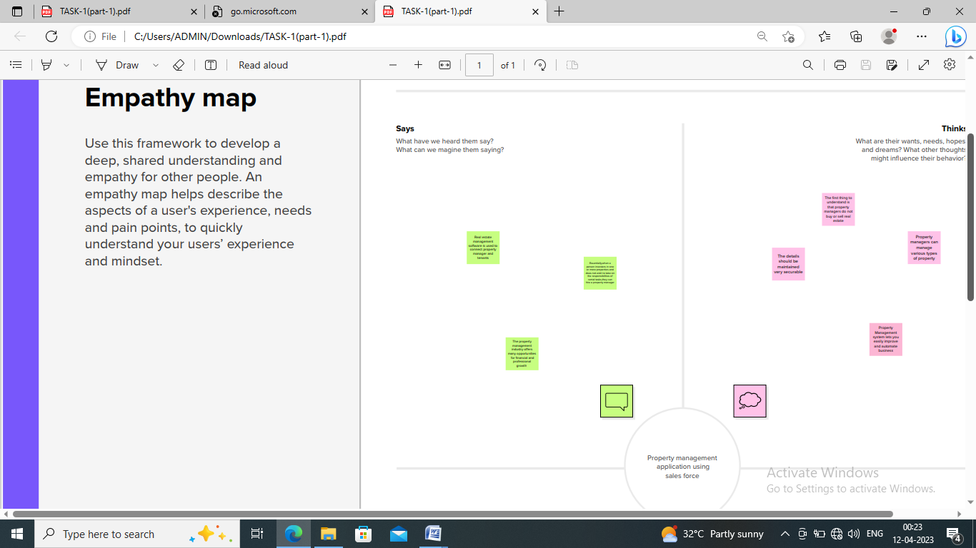

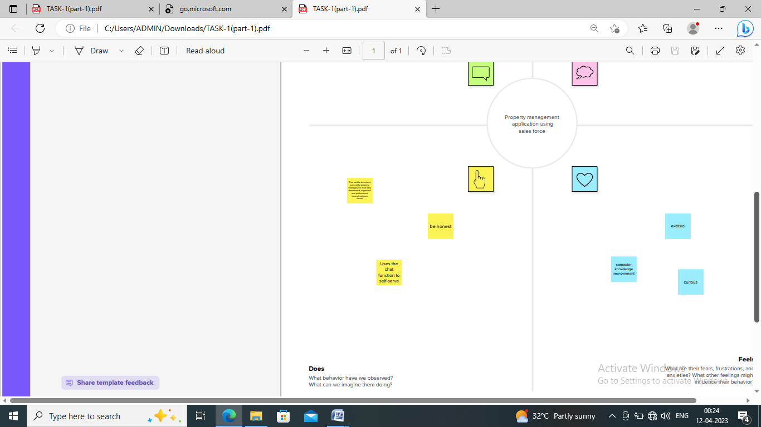

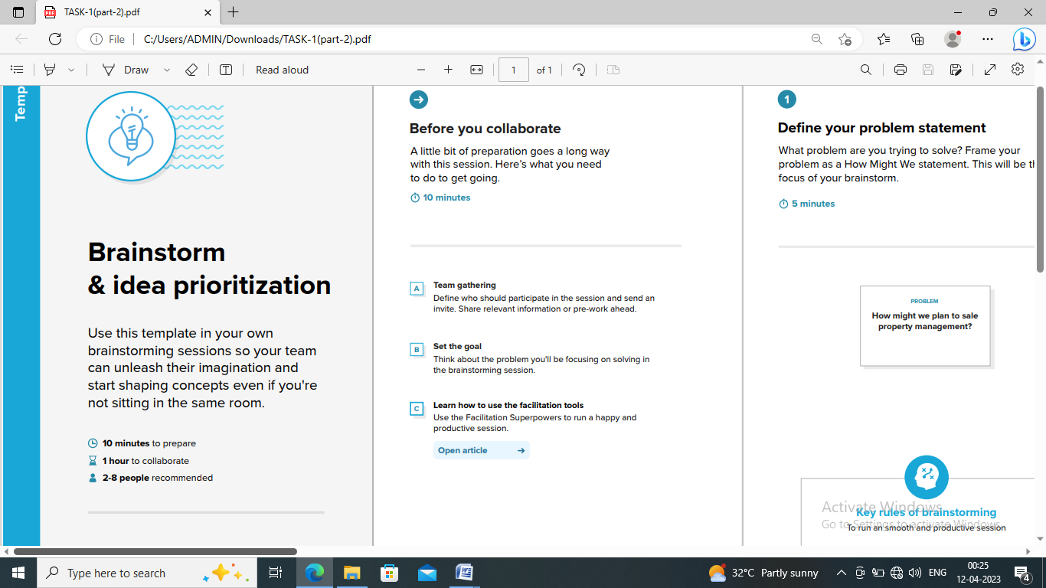

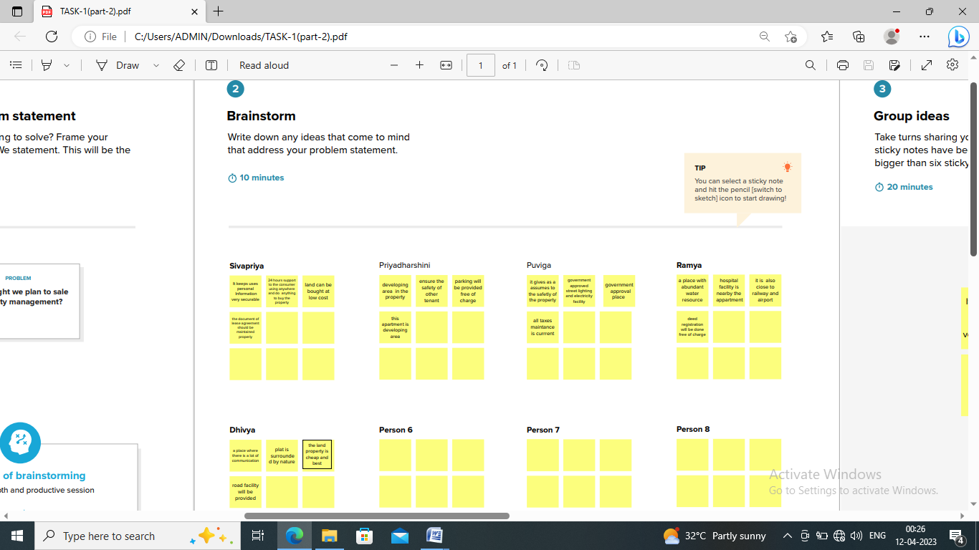

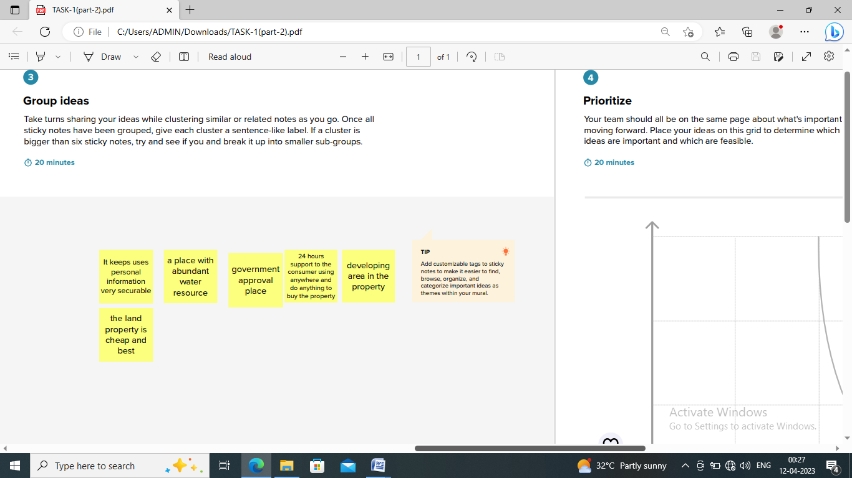

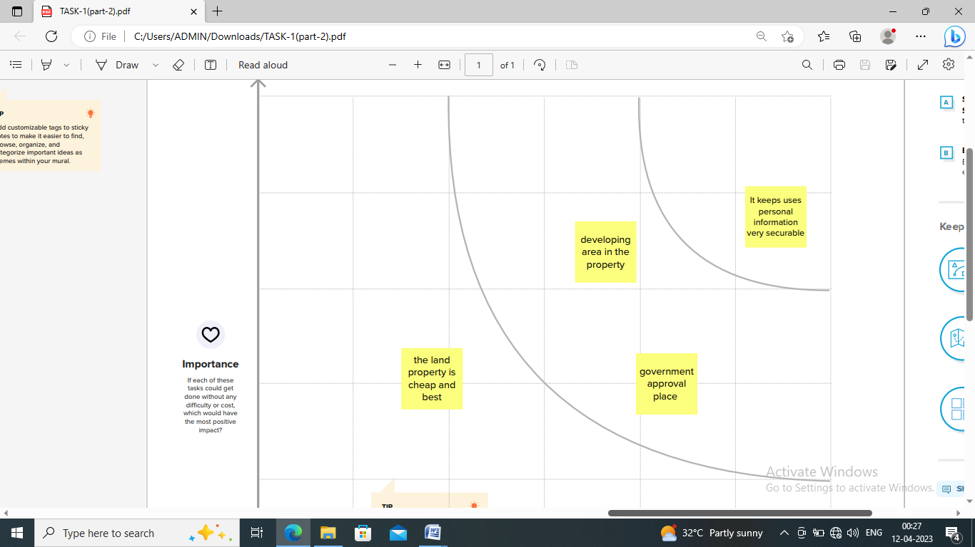

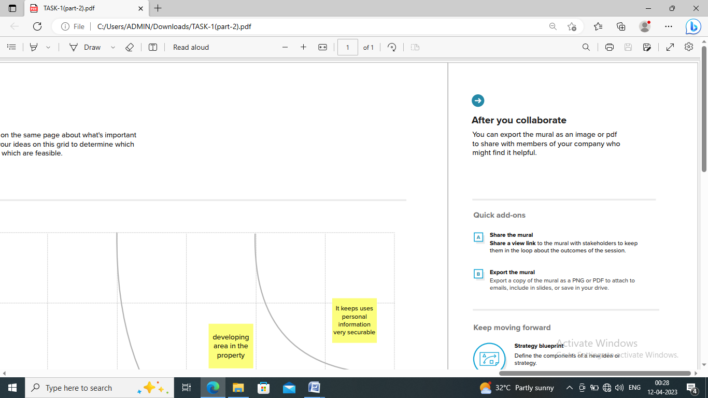

**RESULT**

* Screening potential tenants
* Drafting, signing, and renewing leases on behalf of property owners.
* Collecting rent.
* Property management system (PMS) software is very crucial for all the hotels.

**ADVANTAGES**

Time and energy for you:

* Managers can handle every aspect of managing a rental property.
* This will give you the peace of mind of knowing that your property is well taken care of.

Experience in the industry:

* A property manager likely has years of experience

Managing rental property .

* They know the ins and outs of the market, how

to price market properties effectively.

Tenants retention:

* People often think that once a tenant signs a leave

for your property, the difficult part is over, however, that tenant is not going to stay forever, and at some point, you will have to find a new one.

**DISADVANTAGES**

Lose of control:

* If you are the kind of property owner who wants

To have total control over every aspect of your business, hiring a property manager is certainly not the best call for you.

Expense:

* For the budgets conscious property owner, hiring a property manager may feel like an unnecessary expense.The biggest obstacle people see when determining if they want to hire a property manager is the cost.

**APPLICATIONS**

Property management app for landlords in the smart phone

World .Manage your rental business expenses, income and tenants on

Phone , I pad and webpage.

**CONCLUSION**

Property management system software is very crucial for all

the hotels. Especially Opera PMS constitutes the most appropriate PMS

software for Hilton Athens. It is user friendly , connects with Central

Reservation System (CRS) , point of sale (POS) etc…, and provides all the

tools the hotel needs in order to operate effectively. The disadvantages

of the Opera PMS can be improved easily and as it was mentioned before a recommendation is the upgrade of Opera V5 to Opera 9.

**FUTURE SCOPE**

Property management deals with the management of

Personal, commercial or industrial real estate. The growing population, overall

Economic growth of the country , rising income levels and increased foreign

Investment has led to a heightened need for improved infrastructure across

urban , semi – urban and rural India. The real estate industry in India isolated

to be a 180 billion USD opportunity by 2020.

**APPENDIX**

